ALR Dynamics – Online Incident Reporting System
ALR User Guide

Introduction
This guide provides assistance for Assisted Living Residence (ALR) users of ALR Dynamics – the system of record for the online reporting of required incidents to the Executive Office of Aging & Independence (AGE). ALR Dynamics is a replacement for the former reporting system built with Quick Base software.
The ALR reporting requirements have not changed with the implementation of the new ALR Dynamics system. The new system simply presents the information with a slightly different look and feel, with the intention of better guiding an ALR reporter through communication of all necessary information related to a specific incident.
Please consult ALR regulations 651 CMR 12 for details on now to identify a Reportable Incident.
Contents
Introduction 1
Getting Started 2
Your ALR Dynamics Account 2
First Login 2
Forgot Your Password? 2
Viewing Your Data 2
Viewing Dashboard and Submitting an Incident Report 2
View Your Dashboard 3
Sorting and Searching from your Dashboard 3
Sorting 3
Searching 3
Steps to Submit New Individual Incident Report 4
Submitting a Facility-Wide Incident Report 7
Printing an Incident Report 8
Communications (Notes) and Attachments 9
ALR Dynamics Support 10
User Account Requests 10
Technical Recommendations & Support 12
Document History 12
Appendix A – First Login & Troubleshooting Login Issues 13
Appendix B – Resetting Your Password (Self-Service) 21
Appendix C – Instructions for Multi-Factor Authentication Setup (MFA) When Logging On to the ALR System 23

Getting Started

Your ALR Dynamics Account
Users of ALR Dynamics will receive their credentials via email. The email will contain your system username, a temporary password, and a link to access ALR Dynamics.

First Login
Login to ALR Dynamics with the credentials provided. You will be prompted to update your password to one of your choosing, that meets the stated security requirements.
You will also be required to agree electronically to the data security agreement that appears upon first login before accessing the ALR Dynamics system.
For a detailed description of the first login process, and suggested troubleshooting steps, please see Appendix A – First Login & Troubleshooting Login Issues

Forgot Your Password?
See Appendix B for the steps to reset your own password.

Viewing Your Data
When you login to ALR Dynamics you will be brought directly to your primary dashboard, which is one of several ways that you can view your ALR reporting information. As you become more comfortable with the system, you may prefer other views for working with your reports.
- If you ever “lose” track of your location in the application, you can return to your dashboard by clicking on Dashboards under My Work.
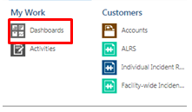

Viewing Dashboard and Submitting an Incident Report
The following walk-through shows an example of how an ALR Reporter would submit a Fall report using the new ALR Dynamics system.
- The basic process is the same for all Incident Reports, although questions vary based on the report type and incident type selected.

View Your Dashboard
Your primary (or “home”) dashboard consists of 3 panels:
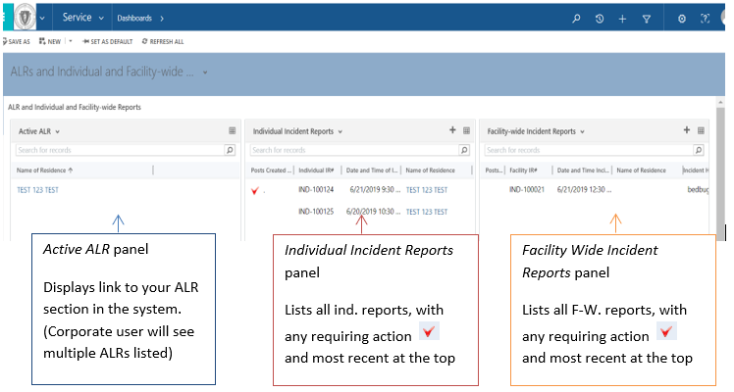

Sorting and Searching from your Dashboard
In ALR Dynamics, you have tools available to find reports that you are looking for.

Sorting
By default, IR dashboard panels are sorted first by ‘new post’ (indicated with red check mark) and then by incident date (newest to oldest.) Click any column heading to sort by that specific field.
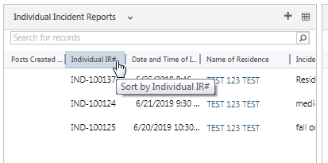

Searching
Each dashboard panel has a search field within it. Enter a report number, name, etc. to find the desired report.
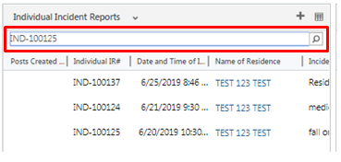

Steps to Submit New Individual Incident Report

- Before creating a new incident report, gather all required information and have it on hand. You will not be able to save the report until all required fields are entered.

- Click on your ALR facility from the Active ALR panel. If you are a corporate user with access to multiple ALRs, click on the facility for which you are submitting an incident report.
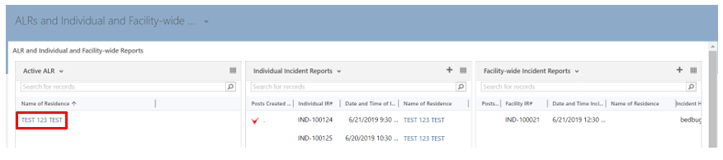
- This brings you to your ALR page, which displays another view of your existing Individual and Facility Wide reports.

- Click on the + symbol to the upper right of the Individual Incident Reports listing.
- This will display a blank, unsubmitted report.
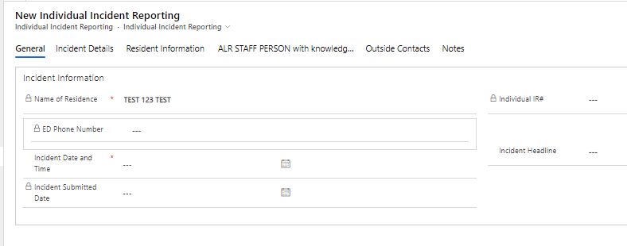
  - These are the sections of the Individual Incident Report form, in the order displayed. Click on each tab to advance to that section:
- General Incident Information
- Incident Details
- Resident Information
- Person with knowledge of this incident
- Outside Contacts
- Notes

- Any question with a red asterisk * is a required field – you will not be able to submit the report successfully if a response to a required question is left blank.
- Any field with a lock symbol cannot be edited by the ALR user. These fields are populated automatically by the system, if required.

- In the General section, add the Incident Date and Time. Select the date from the calendar picker or enter it in with your keyboard.

- You will receive a pop-up prompt to remind you to select the correct time of the incident. The system defaults to 8 AM - take special care to make sure you have entered the precise time of the incident.
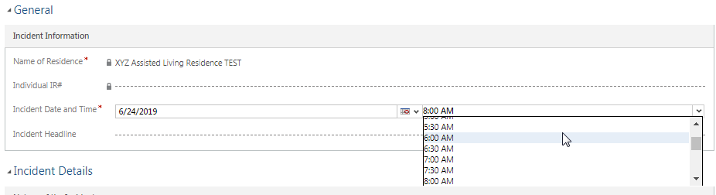
- Enter a brief yet descriptive Incident Headline for the report
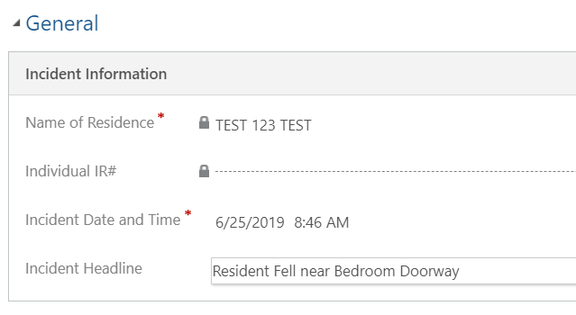
- In the Incident Details section, select the Type of Incident or Nature of Incident from the drop-down listing.
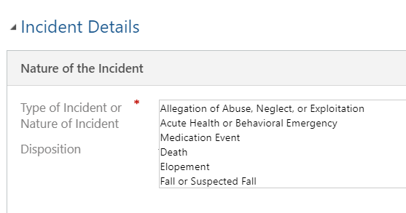
- Depending on the Type of Incident you select, different additional questions will be displayed.

- Complete each required question. Add non-required information if appropriate. As noted, in the narrative section please avoid using identifying information in your description of the incident.
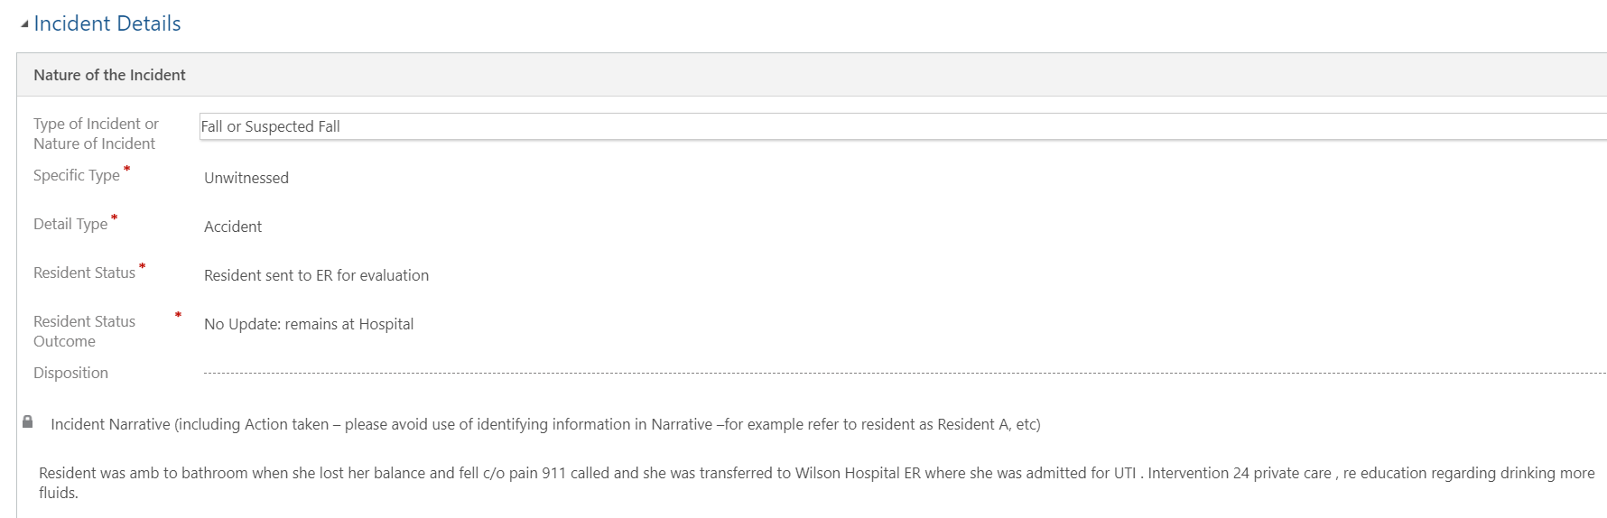
- Complete the Resident Information section with any information you have available.

- The consumer name is permissible in ALR Dynamics because of the increased security of the system.

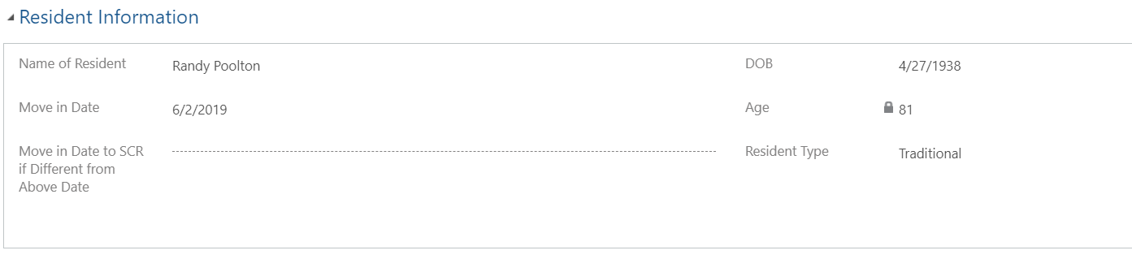

- Complete the remaining sections: Person with knowledge of this incident, and Outside Contacts.

- You can select multiple responses in the Outside Parties Contacted dropdown. The dropdown arrow is located on the far-right side of the response area
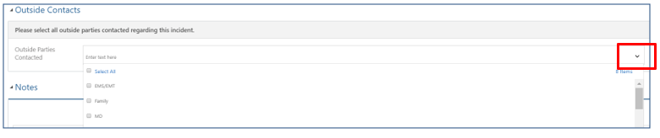
- The Notes tab is where you will find any future communication from the AGE Certification Unit, and where you will attach documents if necessary. Details on that process will be reviewed in a later section.

- Once completed, click the Save button. Save, and additional commands, are located at the top of the incident report screen.

- If you have not entered all the required fields, you will be prompted to complete those field(s) before saving.
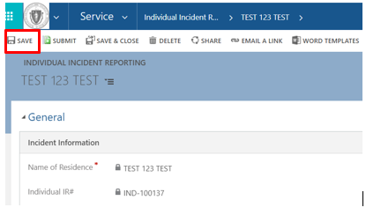
- Once completed and saved, click the Submit button to officially submit the report to the AGE Certification Unit.

- After the report is in Submitted status, you will no longer be able to change any information – except for within the Notes section

Submitting a Facility-Wide Incident Report

- Click on your ALR facility from the Active ALR panel. If you are a corporate user with access to multiple ALRs, click on the facility for which you are submitting an incident report.
- This brings you to your ALR page, which displays another view of your existing Individual and Facility Wide reports.

- Scroll down the page until you see the Facility-wide Incident Reporting Section.

- Click the + New Facility-Wide Incident Reporting button.
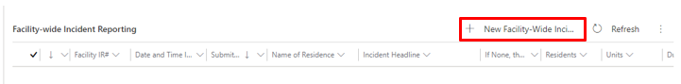
- Complete each section of the Incident Report as required, save, and submit following the same process as you would for an Individual Incident report.

Printing an Incident Report
You can print the full Incident Report by following these instructions:
- Open Incident Report
- At top of screen, click Word Templates and select Individual Incident Report (or Facility Wide Incident Report if applicable.)
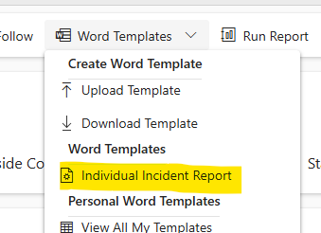
- This will open a ‘Save As’ dialog window. Save in the desired location.
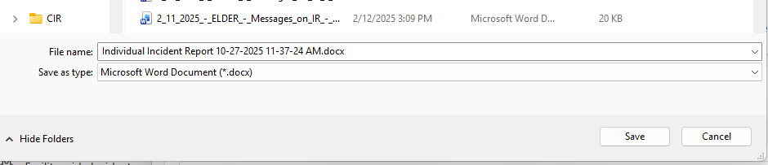
- Navigate to the document location, and print.

Communications (Notes) and Attachments

- Log in frequently to check if there has been a status change on a submitted report, or if AGE has entered a note or requested documentation from you. You should also receive email notifications when AGE has requested information from you regarding a submitted report.

- Login and view your primary dashboard – a red check mark indicates that you have an unread note from AGE. Double click to open.
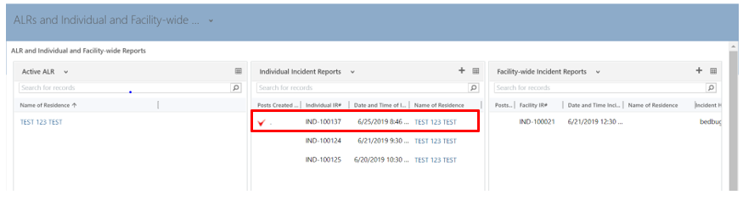
- Scroll down to the Notes section to view the new information.
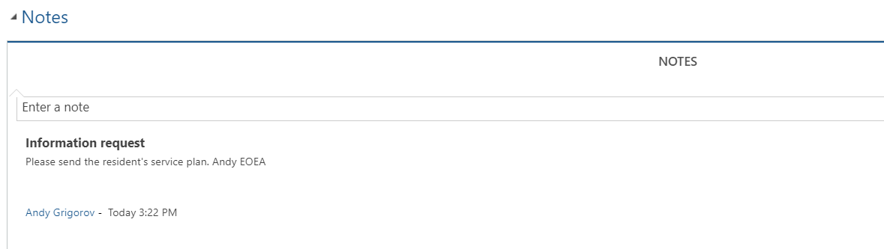
- Attach the requested documentation

- All attachments to incident reports in ALR Dynamics should be in PDF format.

- Add a note confirming the requested document has been attached. This should be the last step before saving and closing a report.

- Save and close the Incident Report.

- During your frequent & routine logins, keep tabs on any more red check marks appearing related to the case. The AGE Certification Unit may have more comments or may request additional information.

- The AGE Certification Unit will change the status of the report to closed, if and when they have completed reviewing and processing the report. You can view the status of the report any time on your dashboard.

ALR Dynamics Support

User Account Requests
Note: The user request process was changed as of 8/31/2021.
User requests include any request to add a new user or edit an existing user. Edits can be user deactivations, name changes, email corrections, etc.
When you make a user request after 8/31/21, you will receive an email from ALR Support with a new version of the User Request Form (URF) with all your current and past users listed.
The new URF looks like this:
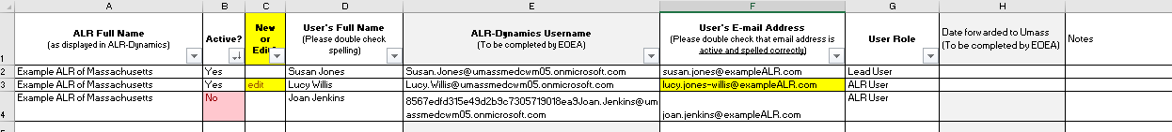
- This same URF, with the latest updates, should be used for all future requests. So, save the updated URF in a safe, accessible place.
- Note that ALRs should not enter anything in the 2 columns labeled with “(To be completed by AGE)”

- To request a new user:
- Clearly state in an email to ALR Support the purpose of your request and attach the completed User Request Form. Describe the change you would like to make, for example: “Please add new ALR user account for Sam Fraterelli, as indicated in the attached form.”
- Put information in new row, under the last complete row
- Make sure that ALR name, user’s full name, and user’s email address are complete and accurate
- Select “New” from the “NEW or EDIT” column
- Type in the appropriate user role, “ALR User” or “Lead User” in column G
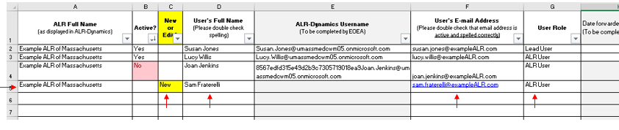
- Send completed form as an attachment to ALR Support at ALRIncidentReport@mass.gov
- After the request is processed, you will receive back an updated form. Keep this updated form for your next request.

- To request a user edit (deactivation, email change, etc.)

- Clearly state in your email to ALR Support the purpose of your request and attach the completed User Request Form. Describe the change you would like to make, for example: “Edit user account email for Lucy Willis. Change email address as indicated on form”

- Make sure that ALR name, user’s full name, and user’s email address are complete and accurate
- Put information on the existing row for the appropriate user.
- Select “Edit” from the “NEW or EDIT” column
- Highlight the box with the requested change, as shown below.
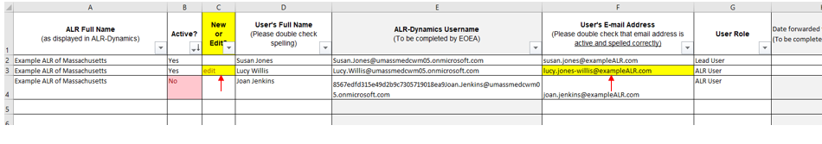
- ALR Expectations:

- ALRs should always have a current and updated list of their ALR-Dynamics system users. If you have misplaced your list, please request it from ALR Support.

- ALRs should save the most recent version of the URF in a place where those staff who make user requests can easily access it.

- ALRs should carefully review the list and deactivate users who no longer need access as soon as possible.

- ALRs should review open reports and respond to questions from AGE in the Notes section, daily.

Updated documentation available here: ALR Support Blog: https://alrir.800ageinfo.com/

Technical Recommendations & Support
- The Internet Explorer browser is not recommended for use with ALR Dynamics.

- Submit any bugs, glitches, and errors in as much complete detail as possible (including screenshots) to ALRIncidentReport@Mass.gov

IMPORTANT! Include this information in your email to support:
  - Your name
  - Your ALR name
  - Detailed description of issue, including:
  - the internet browser you are using
  - what occurred
  - what action was taken before issue occurred
  - screenshot of any error message received
  - Current status (are you able to continue working? what if anything is issue preventing you from doing?)
  - Don’t include resident PI

Document History
version | date | note | author
V1 | 062719 |  | AG
V1.1 | 090419 | Updated ALR email address | AG
V1.2 | 090319 | Added appendix A | AG
V1.3 | 031521 | General updates, email notification info | AG
V1.4 | 083021 | Added updated guidelines for user requests | AG
V1.5 | 012422 | Added section for FW-IRs | AG
V2.0 | 100825 | Added self-serve pw and MFA info as Appendix B; updated branding to AGE | AG

Appendix A – First Login & Troubleshooting Login Issues

If you have trouble logging into ALR, it may help to login using Chrome Incognito. Follow the steps outlined below:

- Open Google Chrome
- Once in Google Chrome, select New incognito window (see picture below):
- You will see this screen:

- Copy and paste or type in this URL: https://umassmedcwm05.crm.dynamics.com/main.aspx
- You will see the screen below
- Use the credentials sent to you for the Dynamics System. Credentials will be your firstname.lastname@umassmedcwm05.onmicrosoft.com

- Select Next
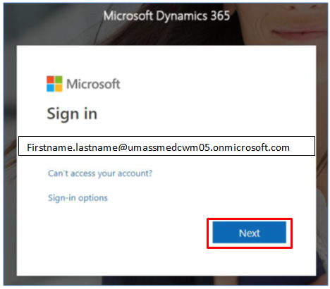
- Enter your password and click Sign In.
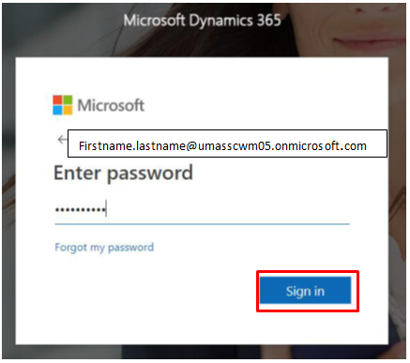

- A prompt will come up to change your password:
  - Current Password: enter the password provided to you previously (PASSWORD IS CASE SENSITIVE)
  - New Password (at least 8 charters with at least one capital letter and a number and special character)
  - Confirm Password (renter your new password)

- Select Sign in

- A new screen will appear requiring signing of the Non-UMMS User Agreement
- You must click on the document and view it.
- After you view the document select Accept

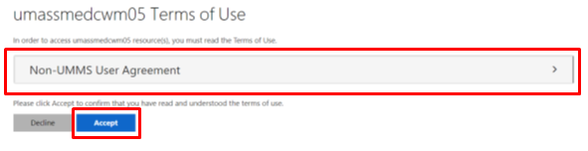
- A new screen will appear – Select Next

- A screen prompting you to confirm your password will display
- Select re-enter my password

- Please check to make sure your username is displayed.
- If it is displaying, type in the password you just created. Sign in
- If you share a computer, the previous user may appear here. If it is a different username – select Sign in with another account
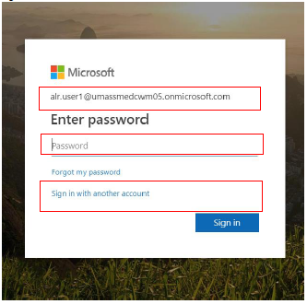
[Skip if already signed in with your user account]
- Select User another account
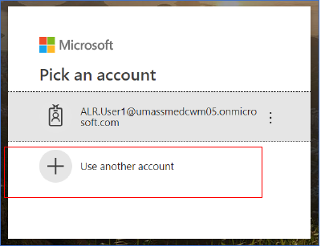
- Type in your username, and select Next
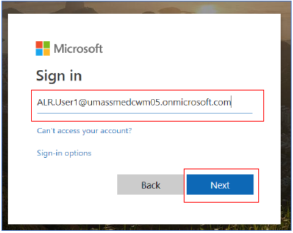
- Type in the password you just created, and click Sign in
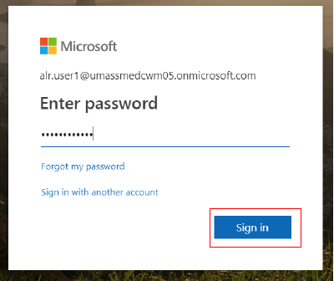
Select No when this screen displays and Don’t show this again
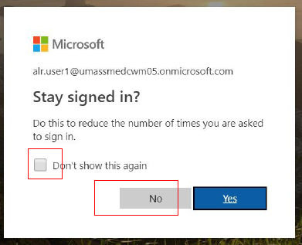
- Select the way you want to receive a password reset if you forget your password. This needs to be a phone number or a valid email address.
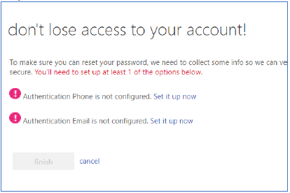
- An authentication code will be sent to the email or phone number you indicated.
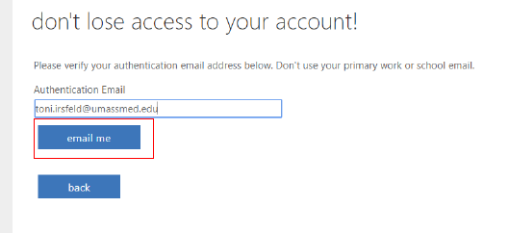
- Copy the code from your email or phone message
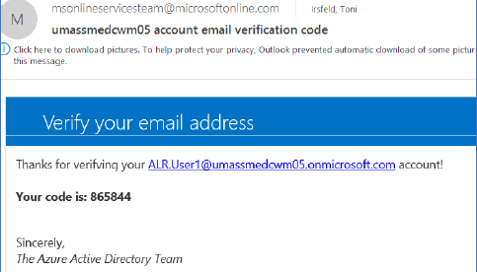
- Enter the code and click on verify
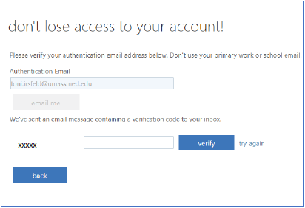
- Select Finish
- You should now be logged into the database
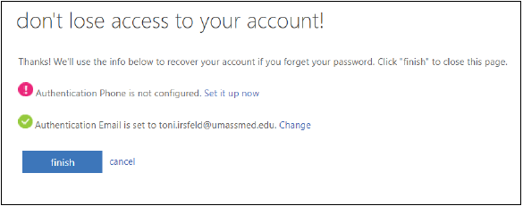

Appendix B – Resetting Your Password (Self-Service)
Dynamics includes a convenient self-service password reset function. There are two ways to access this function:
  - Click “Forgot my password” on the login page (https://myapps.microsoft.com), as shown below:
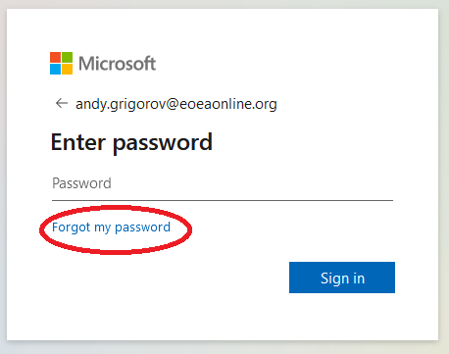
  - OR, Go directly to https://passwordreset.microsoftonline.com
Next, the “Get back into your account” prompt is displayed, as shown below. Provide responses
to the prompts and click Next.
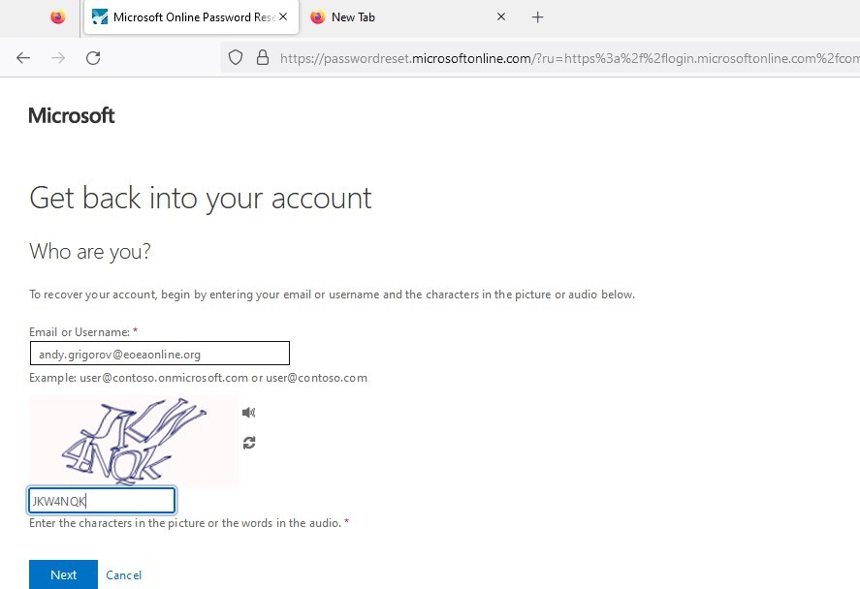

Next, you’ll be prompted to use one of the security access methods you specified during account setup, to verify your identity and reset your password (see image below).
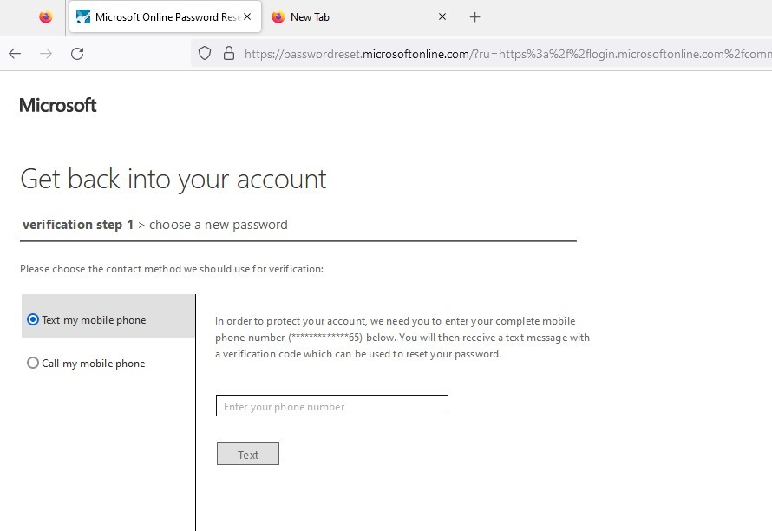
After you’ve verified your identity, you’ll be prompted to specify your new password, as shown
below:
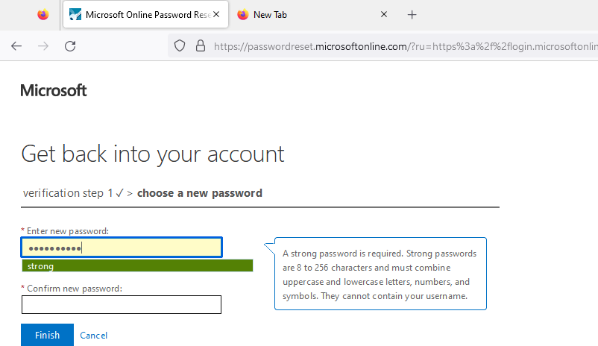

Appendix C – Instructions for Multi-Factor Authentication Setup (MFA) When Logging On to the ALR System

With multifactor authentication configured, users will now have a more secure two-step process for connecting to the ALR system. In summary, the two-step connection process will now be: (1) Enter your username and password as usual; and (2) Respond to a prompt sent to your phone.
NOTE: You will need a phone to perform these setup steps.

INSTRUCTIONS FOR Multi-Factor Authentication Setup When Logging On To the ALR System

- After entering your username and password as usual, the system will display a prompt with the headline “Let’s keep your account secure” as depicted below. Click Next on this prompt.
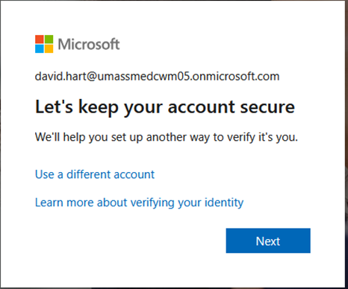

- The next screen displayed is titled “Keep your account secure” depicted on the top of Page 2. On this screen, you’ll specify whether you want the 2nd step of your sign-in to be a phone call to your phone, or a six-digit code sent to your phone as a text message. To complete this screen:

  - Enter your 10-digit phone number, without parentheses, etc. in the Phone number field (for example, enter 6175551030)

  - In the Choose how to verify section, choose your preference of “Receive a code” or “Call me”. In the screen example below, the user has chosen to receive a text message containing a six-digit code.

  - Click Next in the lower-right corner of the screen.

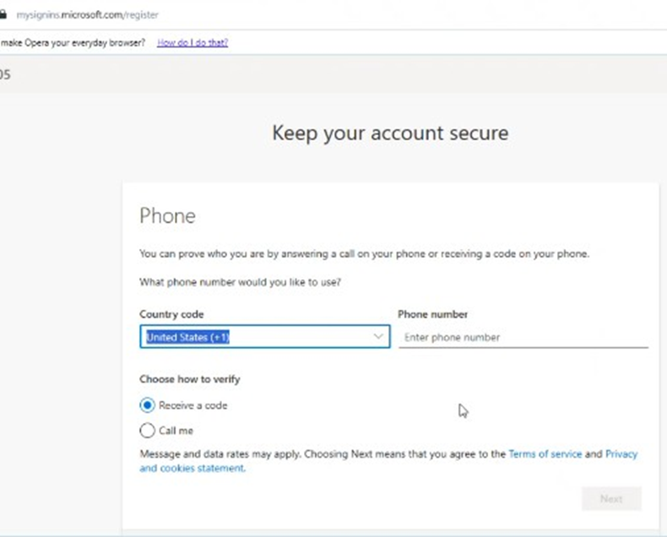

- Next, the system will conduct a test of your new phone-based verification method, to make sure it works (see screen image below). If you chose “Receive a code”, you will receive a text message containing a six-digit code. If you chose “Call me”, you will receive an automated phone call with a verbal prompt to complete the verification. NOTE: The screen image below is for a user who chose the “Receive a code” authentication method.
After you complete the prompt, press Next.

- After successful completion of Step 3, the system displays two success messages. Both messages are depicted below, in sequence. Click Done on the second success message. Then, you will proceed to the ALR system (see images further below).
From this point forward, you’ll be prompted for phone verification each time you access
the ALR system!

- After you click Done in Step 4, you’ll proceed into the ALR system as depicted in the
screen images below:

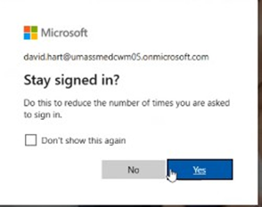

Select Sales Team Member, if offered various options shown below:
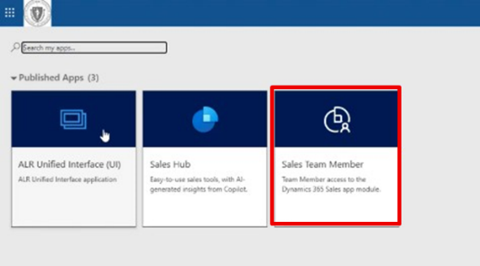
IMPORTANT NOTE: From this point forward, each time you connect to the ALR system you’ll
be prompted for (a) your username and password and (b) your phone verification.

