# How to Reset Your Password (Self-service)

The new environment includes a convenient self-service password reset function. There are two ways to access this function:

* + Click “Forgot my password” on the login page ([https://myapps.microsoft.com](https://myapps.microsoft.com/)), as shown below:

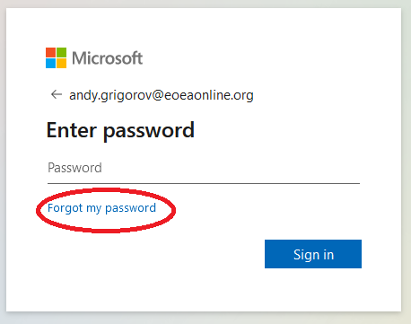

* + OR, Go directly to [https://passwordreset.microsoftonline.com](https://passwordreset.microsoftonline.com/)

Next, the “Get back into your account” prompt is displayed, as shown below. Provide responses

to the prompts, and click Next.

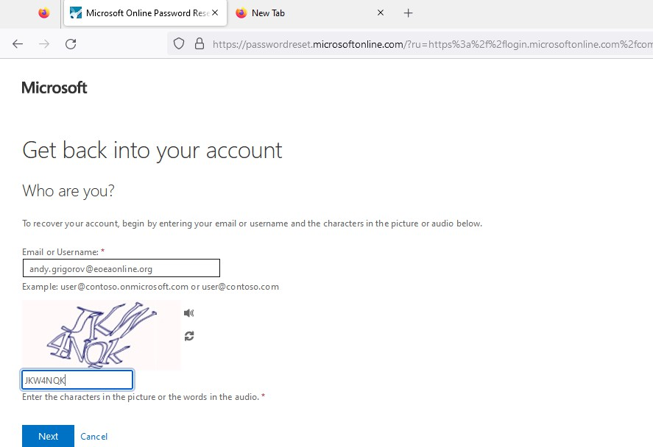

Next, you’ll be prompted to use one of the security access methods you specified during account setup, to verify your identify and reset your password (see image below).

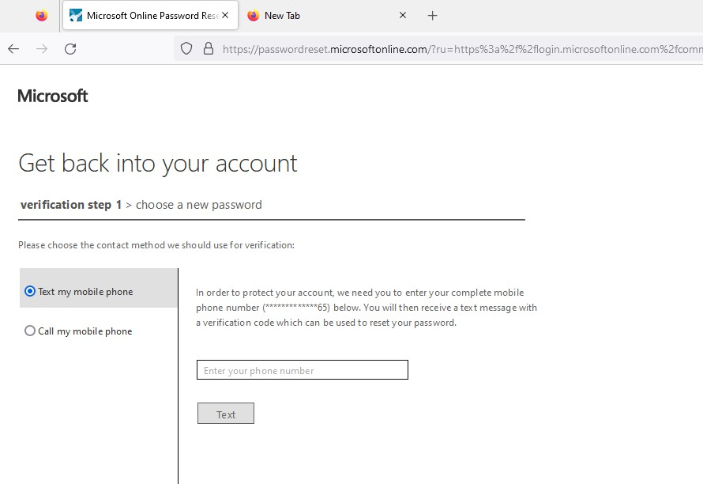

After you’ve verified your identity, you’ll be prompted specify your new password, as shown

below:

