Change to ALR System Sign-On Steps
The Assisted Living Residences (ALR) Incident Reporting System is developed using a case management system called Microsoft Dynamics. Recently, Microsoft implemented new security settings in this environment. With these new security settings, many users (but not all) will now need to register for Multifactor Authentication (MFA) the next time they log in to the system. This document is intended to guide users through these MFA set-up steps.

With multifactor authentication configured, users will now have a more secure two-step process for connecting to the ALR system. In summary, the two-step connection process will now be: (1) Enter your username and password as usual; and (2) Respond to a prompt sent to your phone.
NOTE: You will need a phone to perform these setup steps.

INSTRUCTIONS FOR Multi-Factor Authentication Setup When Logging On To the ALR System

- After entering your username and password as usual, the system will display a prompt with the headline “Let’s keep your account secure” as depicted below. Click Next on this prompt.
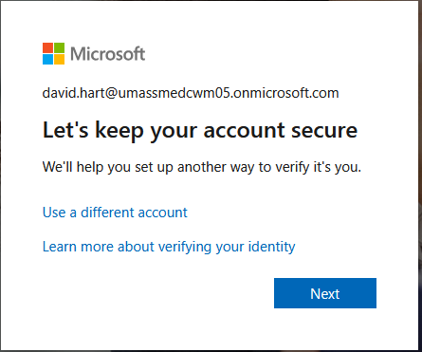

- The next screen displayed is titled “Keep your account secure” depicted on the top of Page 2. On this screen, you’ll specify whether you want the 2nd step of your sign-in to be a phone call to your phone, or a six-digit code sent to your phone as a text message. To complete this screen:
  - Enter your 10-digit phone number, without parentheses, etc. in the Phone number field (for example, enter 6175551030)
  - n the Choose how to verify section, choose your preference of “Receive a code” or “Call me”. In the screen example below, the user has chosen to receive a text message containing a six-digit code.

  - Click Next in the lower-right corner of the screen.

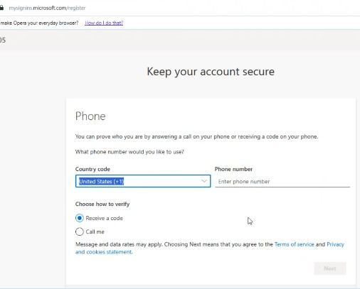
.

- Next, the system will conduct a test of your new phone-based verification method, to make sure it works (see screen image below). If you chose “Receive a code”, you will receive a text message containing a six-digit code. If you chose “Call me”, you will receive an automated phone call with a verbal prompt to complete the verification. NOTE: The screen image below is for a user who chose the “Receive a code” authentication method.
After you complete the prompt, press Next.
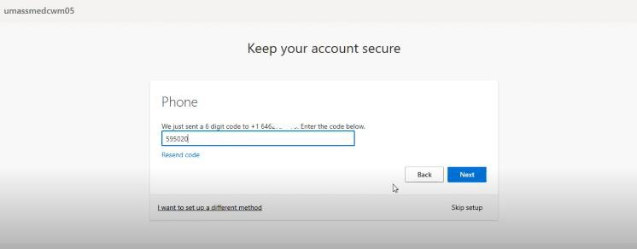

- After successful completion of Step 3, the system displays two success messages. Both messages are depicted below, in sequence. Click Done on the second success message. Then, you will proceed to the ALR system (see images further below).
From this point forward, you’ll be prompted for phone verification each time you access
the ALR system!
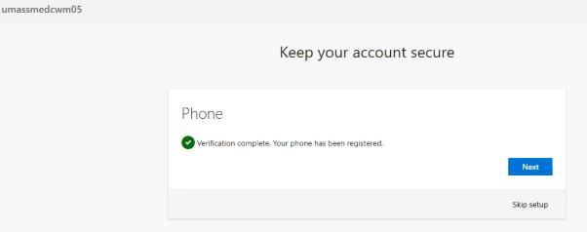
- After you click Done in Step 4, you’ll proceed into the ALR system as depicted in the
screen images below:
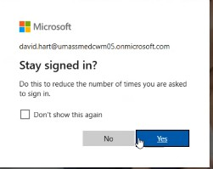
Select Sales Team Member, if offered various options shown below:
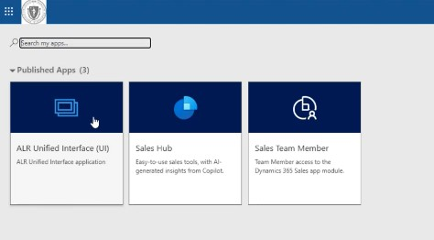
IMPORTANT NOTE: From this point forward, each time you connect to the ALR system you’ll
be prompted for (a) your username and password and (b) your phone verification.

